

CMP 327 Open test



February 9, 2024

Code five

Bingham University

Matriculation Numbers

Onigbode Nathan BHU/21/04/05/0027

Yashim Kelvin Jacob BHU/21/04/05/0081

Abu’Saed Jeremiah BHU/21/04/05/0002

Anishe Eniola BHU/21/04/05/0022

Okoro Progress BHU/21/04/05/0089

Ismail Maryam BHU/23/04/05/0116

QUESTION 4: With the aid of diagram, Discuss the Information Retrieval Process.

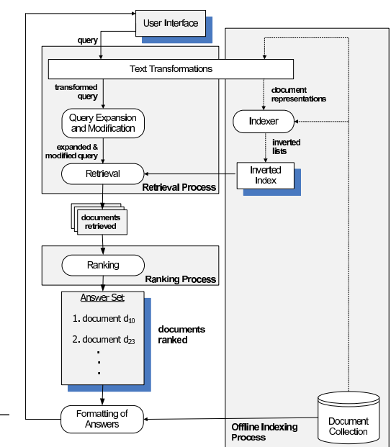

As seen from the diagram, the user interface provides an interface whereby the user can send in a query to the system, the query moves through a text transformation and then goes to a section where it will be expanded and modified. Upon modification, the documents will be retrieved and ranked according to a process. After ranking, there will be a formatting of answers which will be collected and stored for future indexing processes. The final answer will also be sent back to the user interface for the user to use the answer as he wants.

A Query is a statement requesting the retrieval of information. The portion of a data manipulation language that involves information retrieval is called a query language.

QUESTION 7: With the aid of diagram, explain the three-level architecture of DBMS.

1. What is a database schema?
2. What is data independence in your understanding?

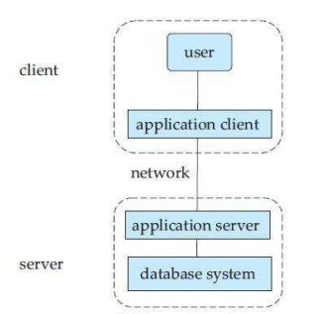

1. The database schema is the logical design of the database. It shows the dependencies between the primary and the foreign key. Each relation appears in a box with the relation name at the top and the attributes listed inside the box. Primary key attributes are shown underlined. Foreign key dependencies appear as arrows from the foreign key attributes of the referencing relation to the primary key of the referenced relation.
2. Data independence in a database system is when the DBMS provides an interface between the application programs and the data. When changes are made to the data representation, the meta data obtained by the DBMS is changed but the DBMS continues to provide the data to application programs in the previously used way. The DBMS handles the task of transformation of data where necessary.